**SE Experiment 3**

**Aim:** Identify scenarios & develop UML Use case and Class Diagram for the project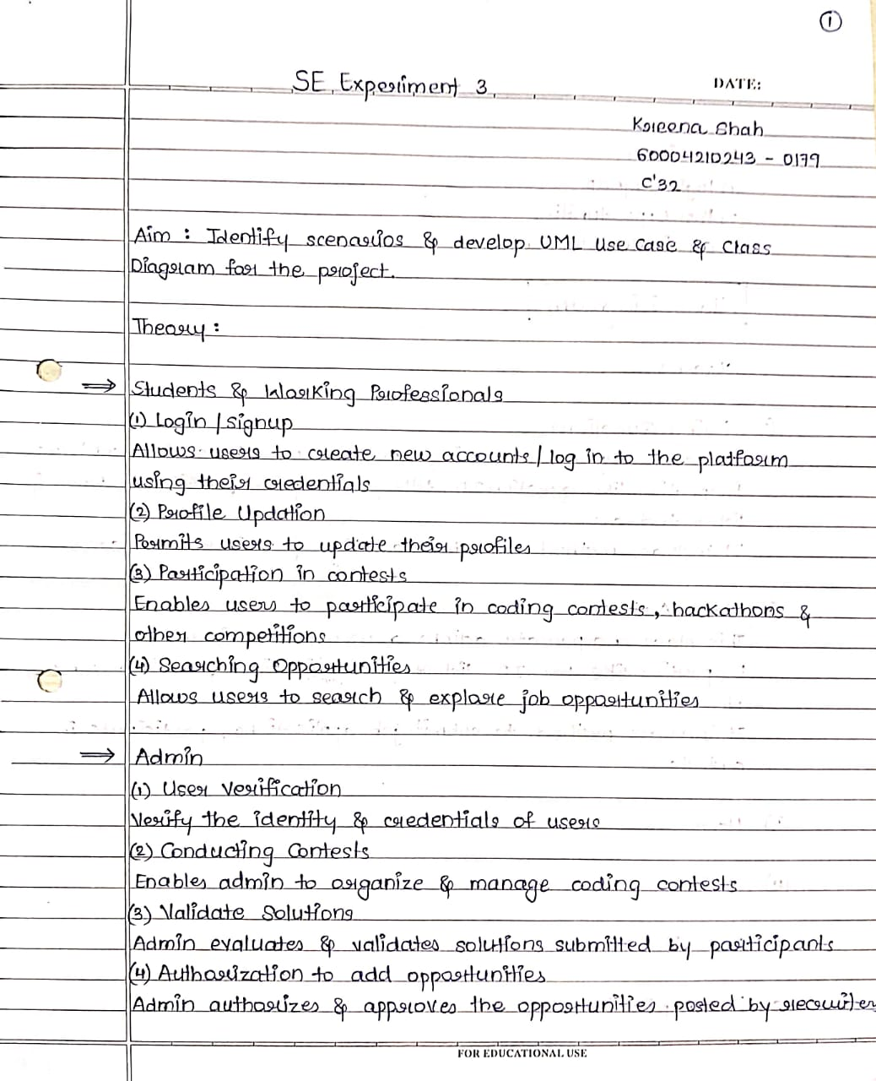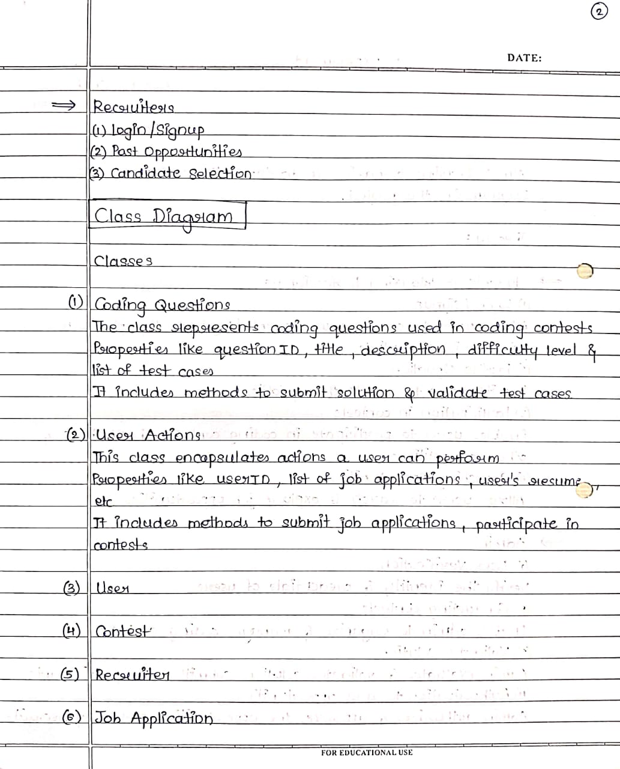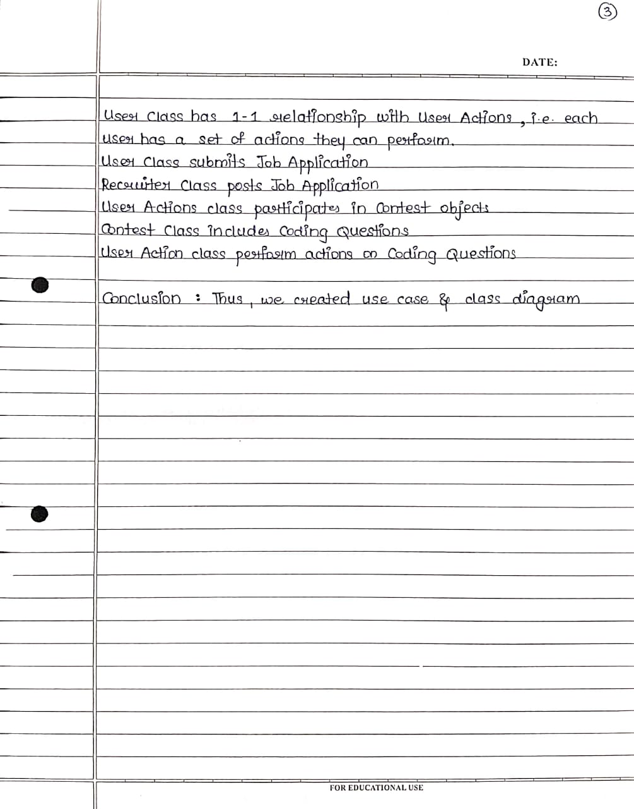

**Use Case diagram**

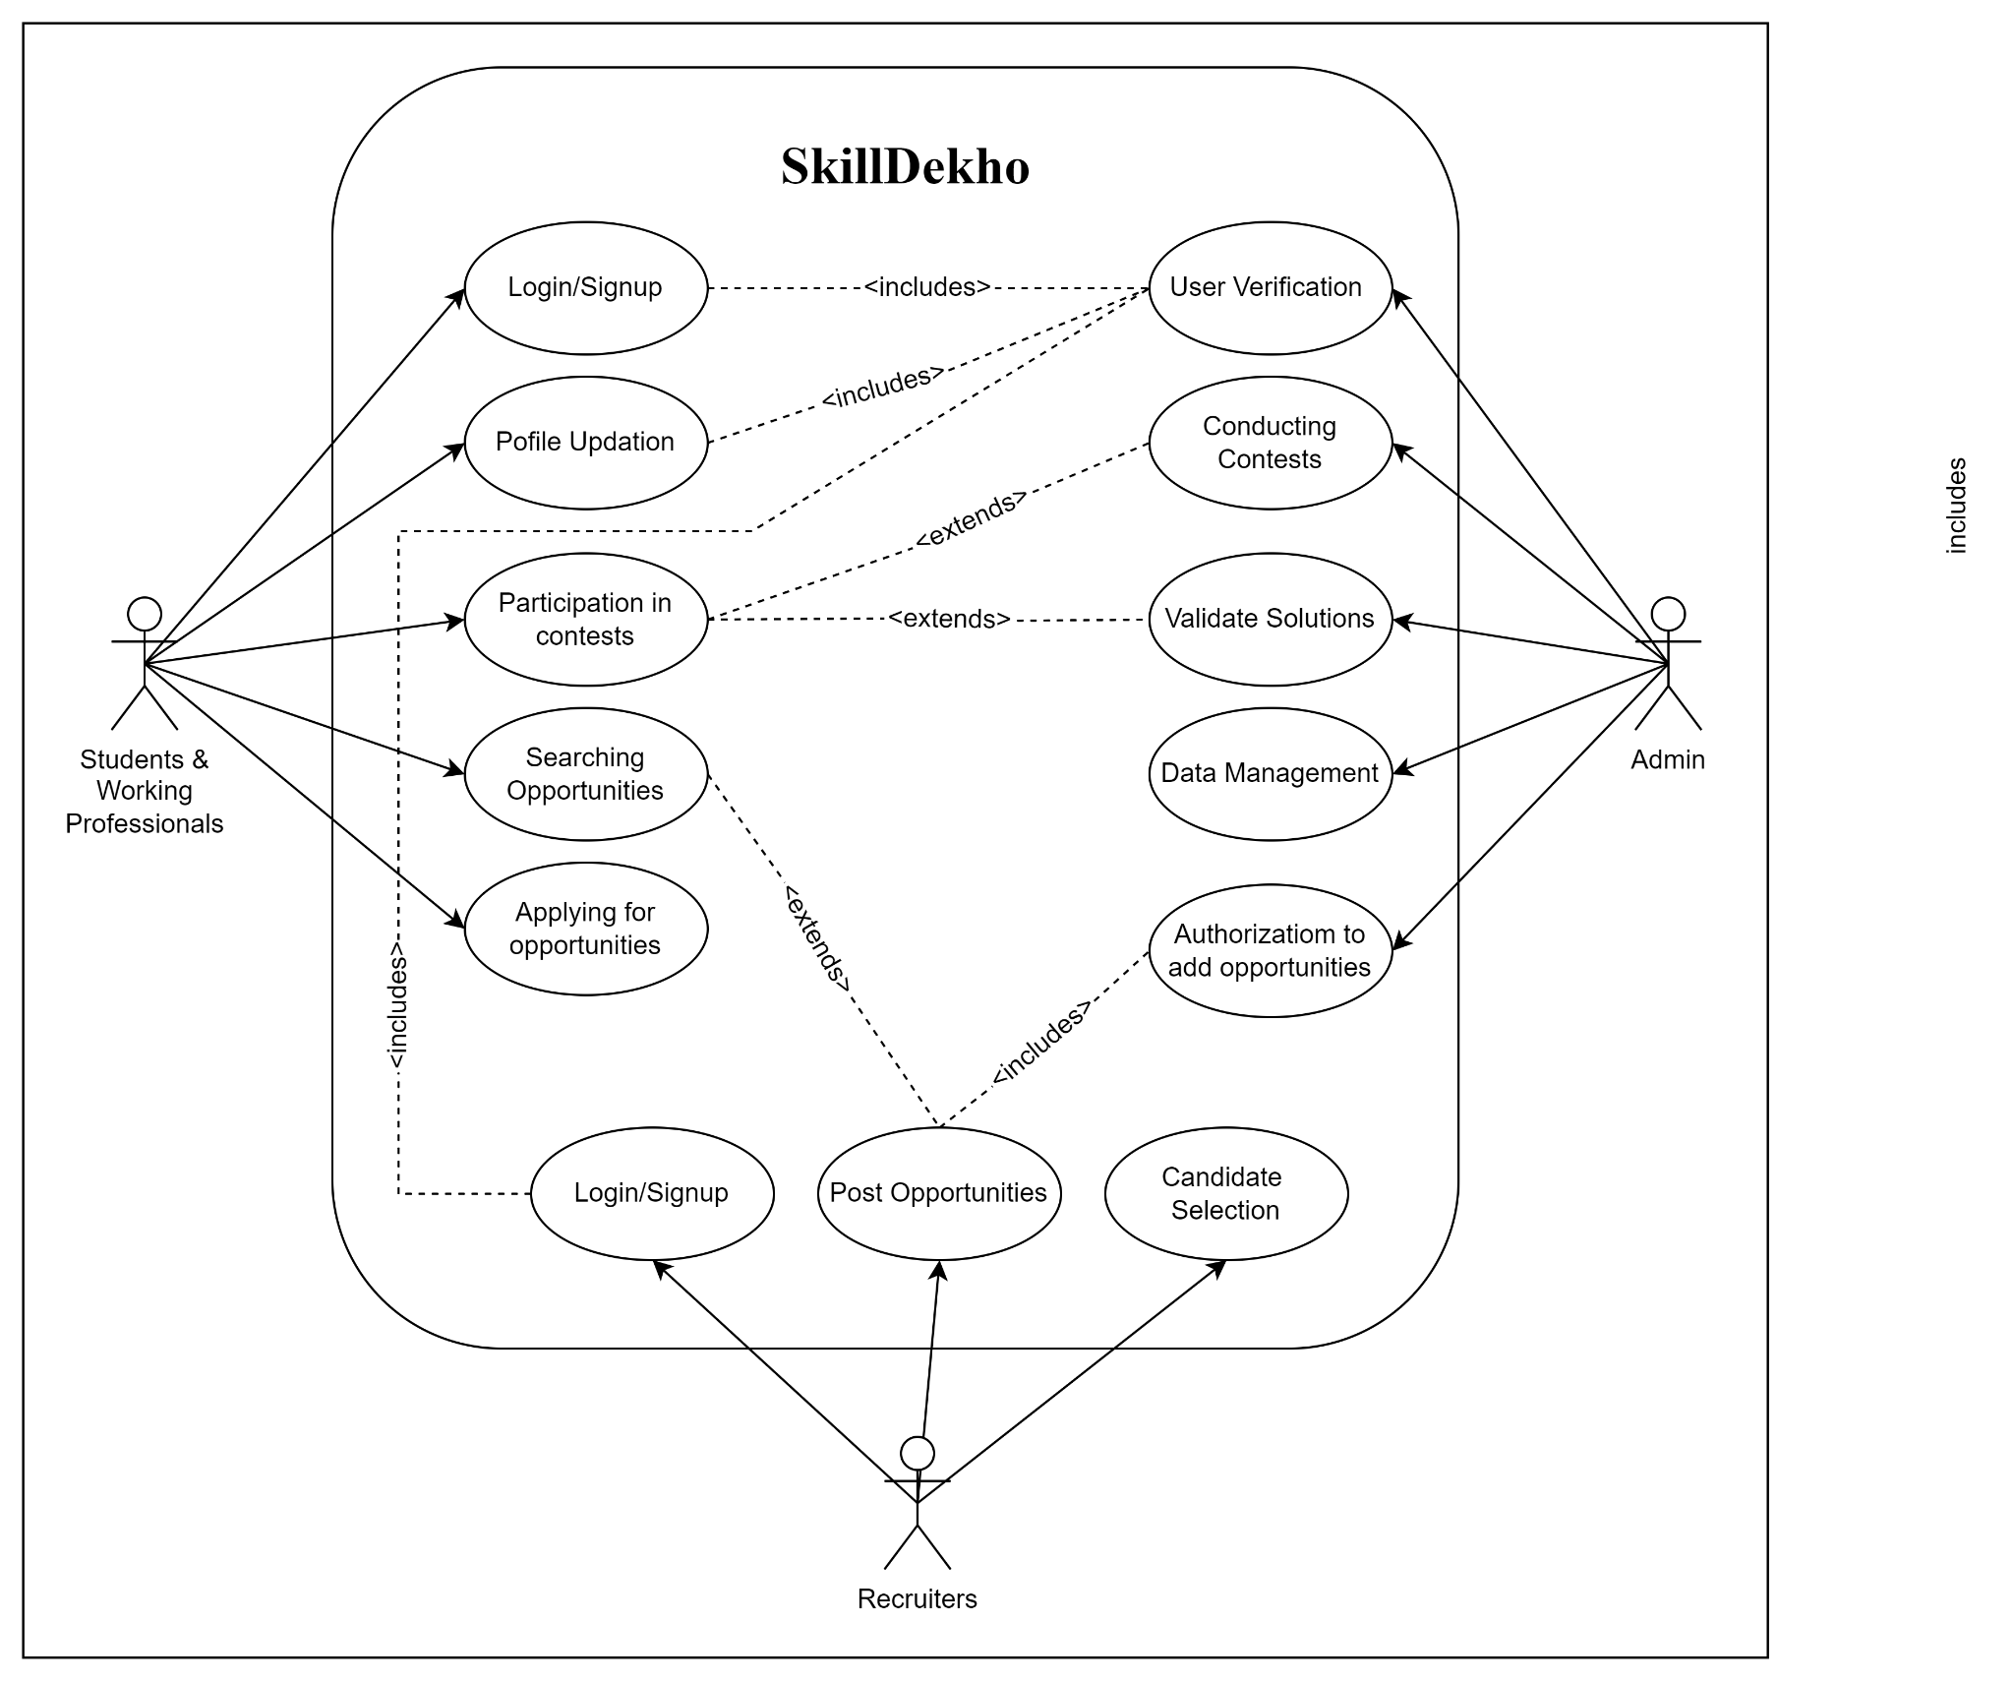

**Class diagram**

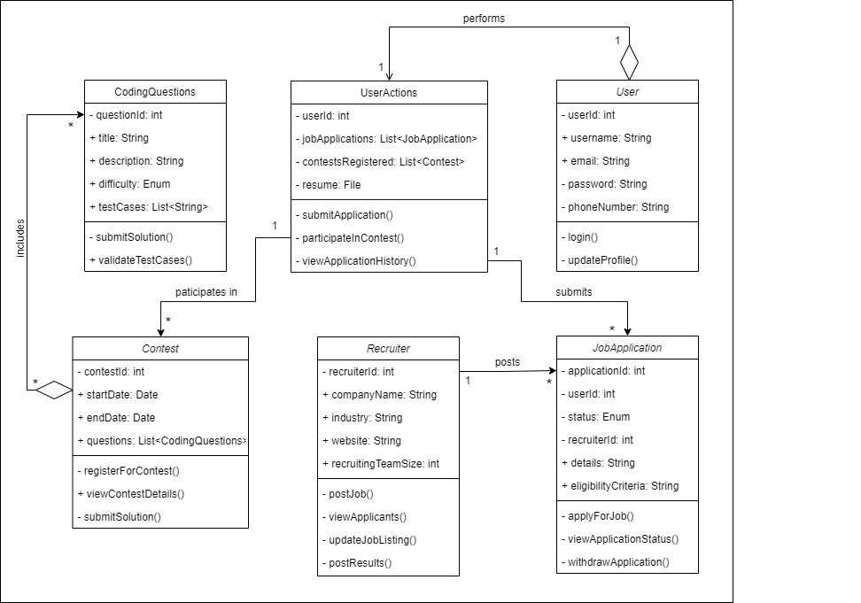

**Conclusion:** Therefore we have implemented use case and class diagram for our project SkillDekho

**SE Experiment 4**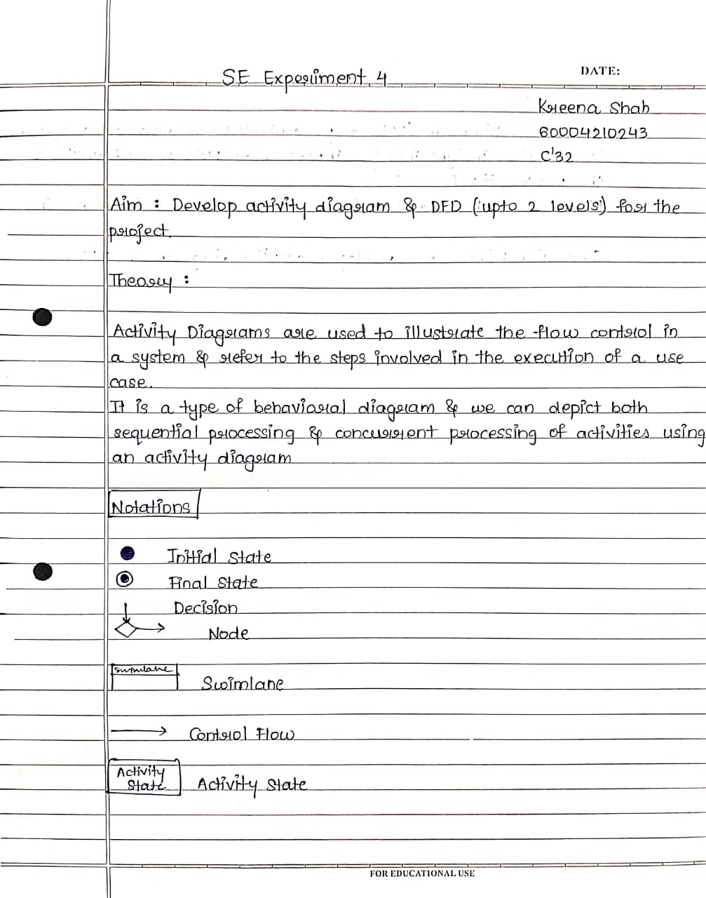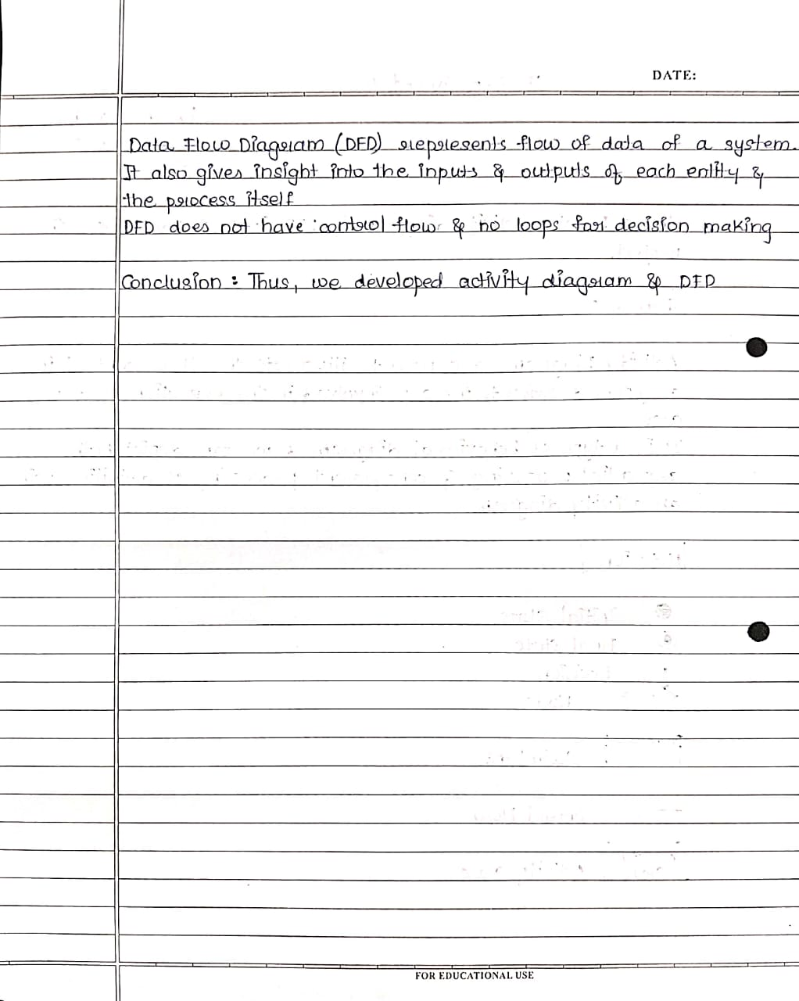

**Activity Diagram**

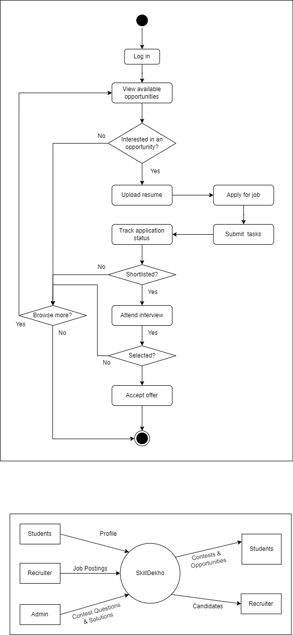

**Swimlane**

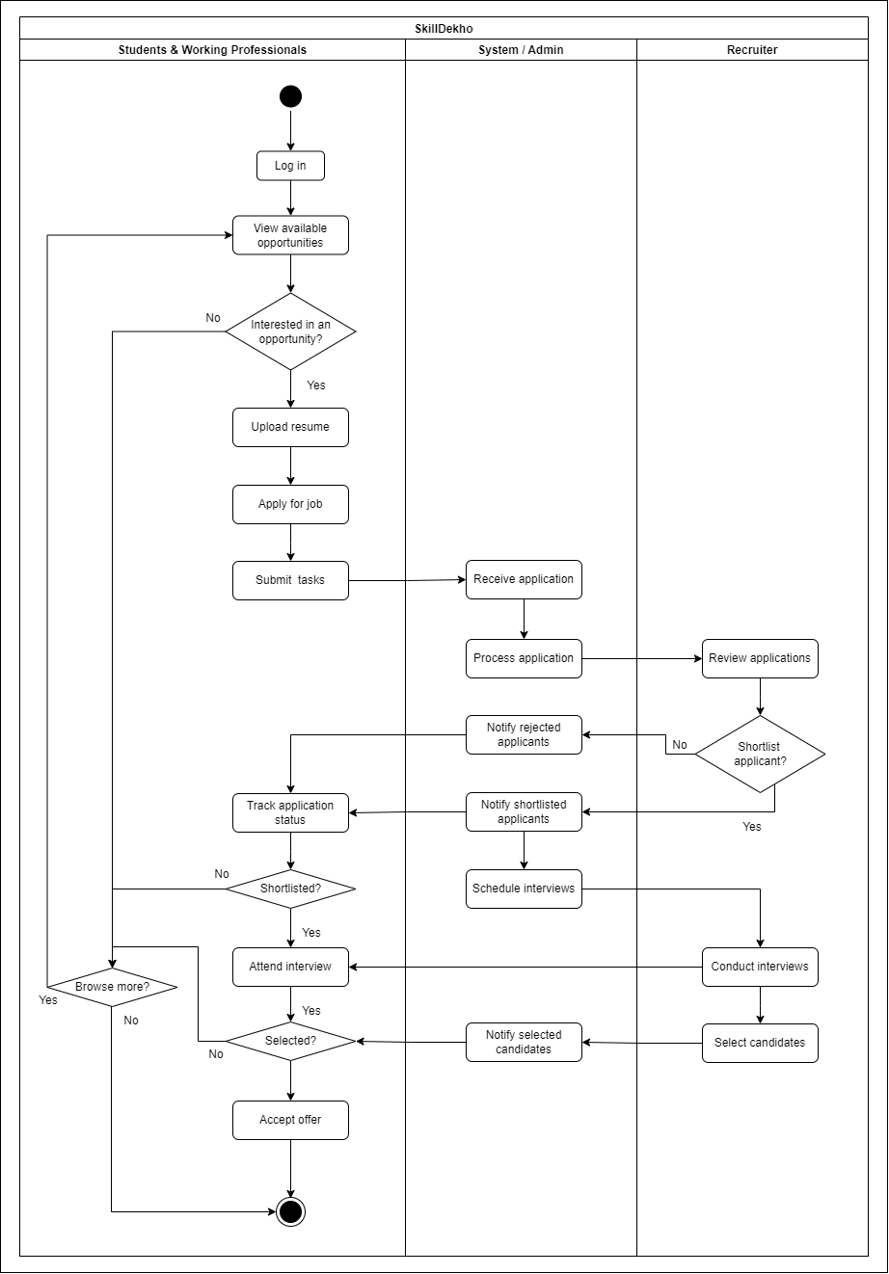

**DFD**

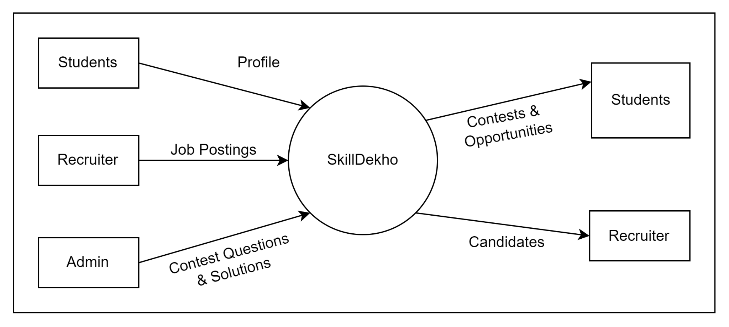

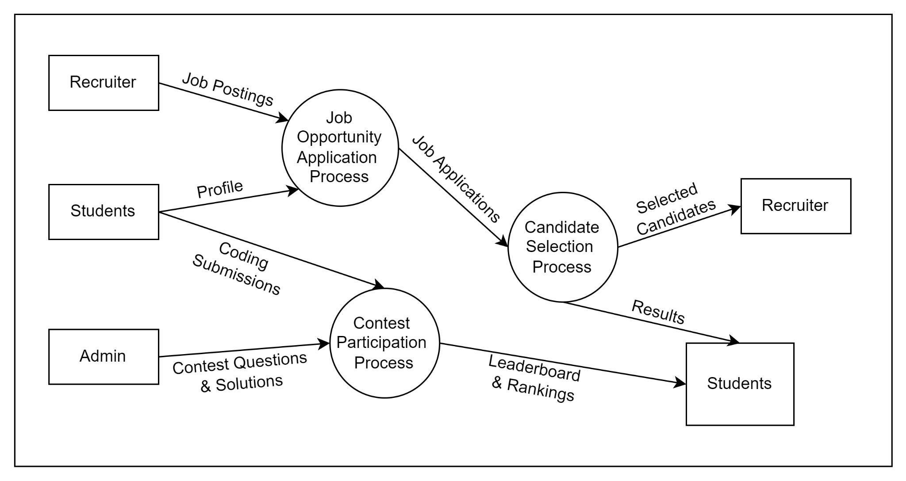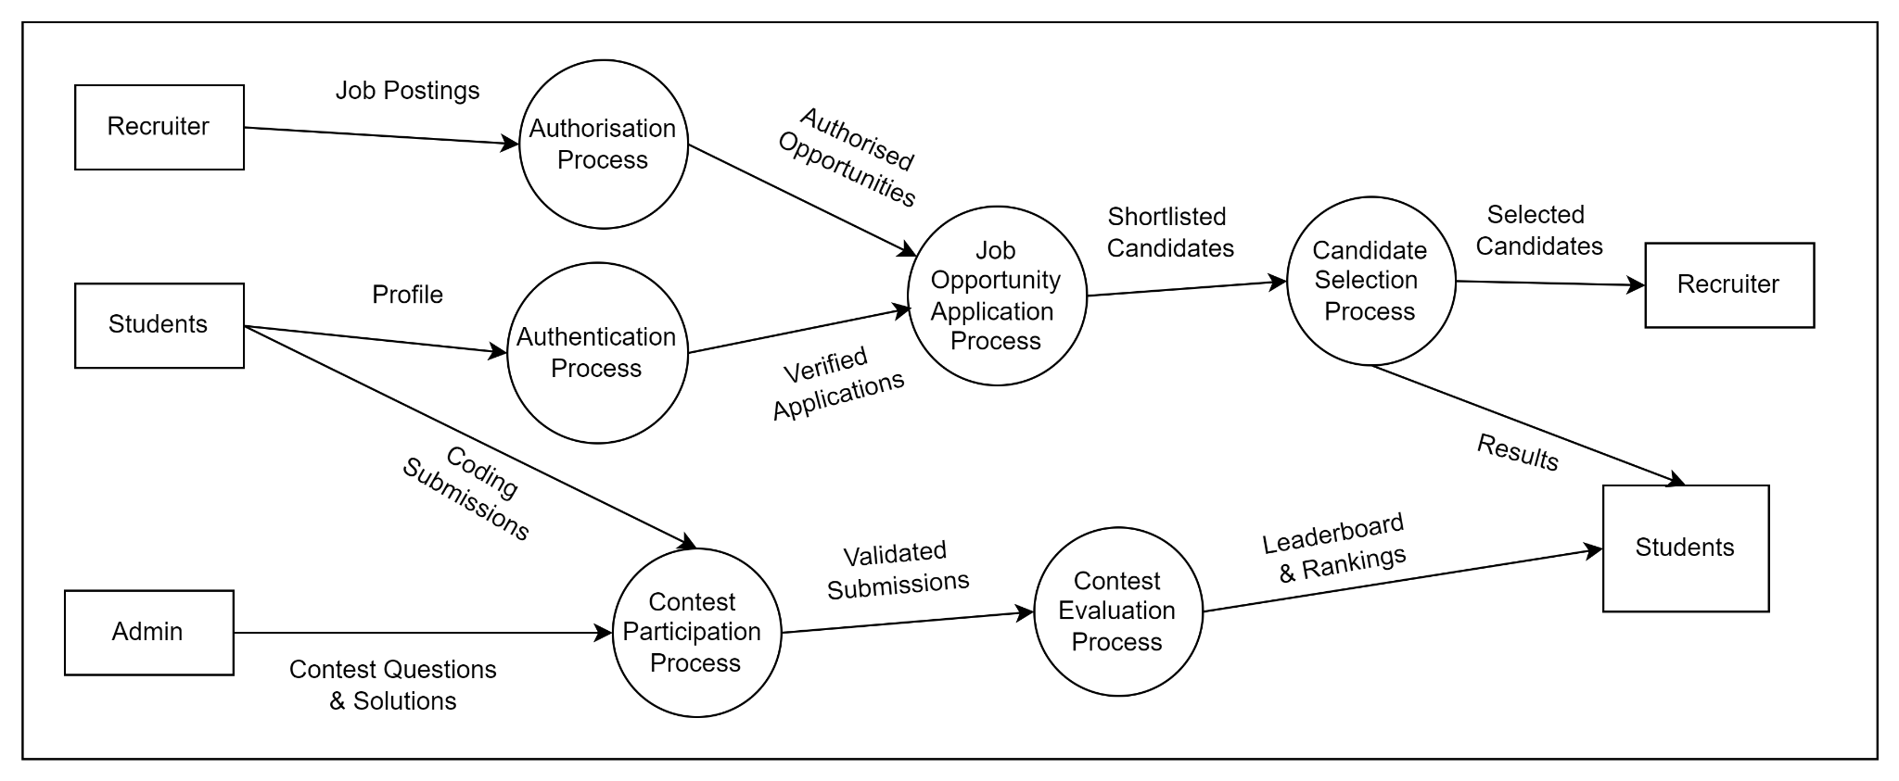

**Conclusion:** Therefore we have implemented Activity diagram and DFD for our project SkillDekho

**SE Experiment 5**

**Aim:** Develop Sequence, Collaboration and State diagram for the project.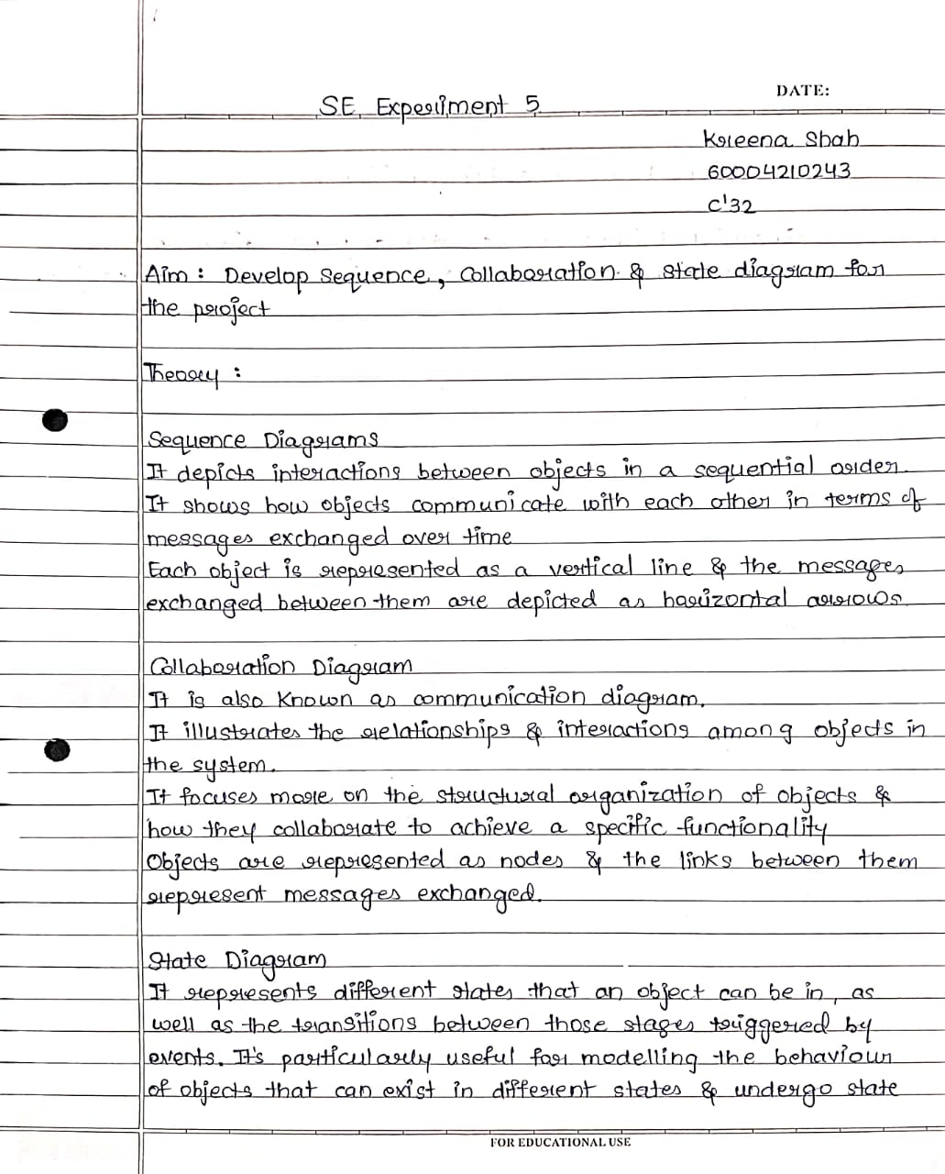

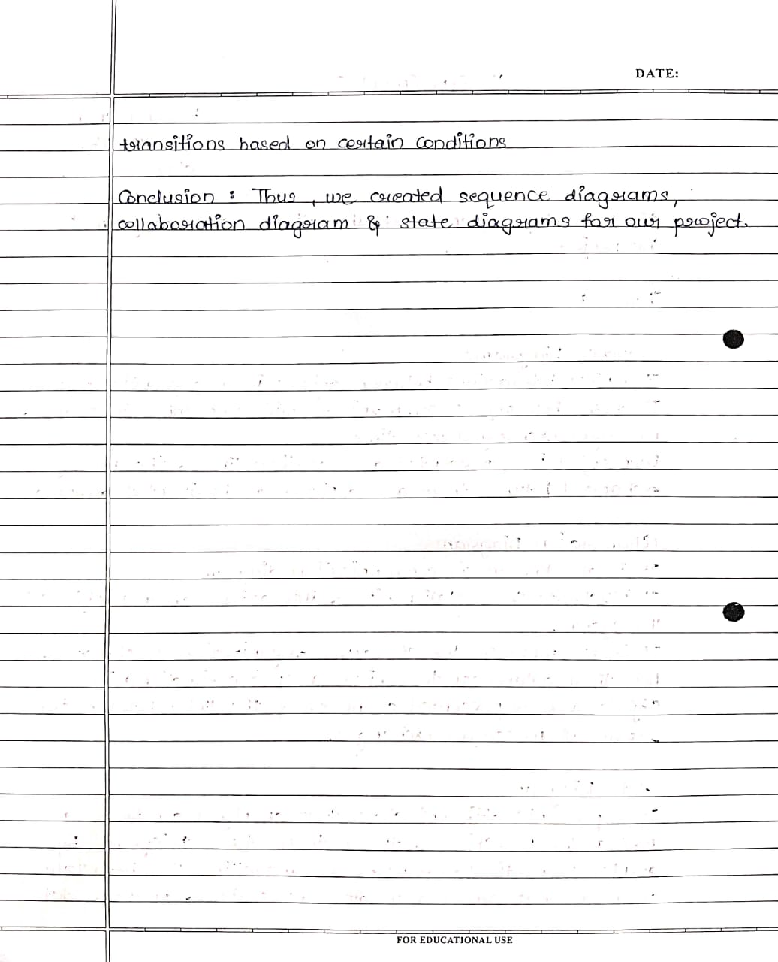

**Sequence Diagram**

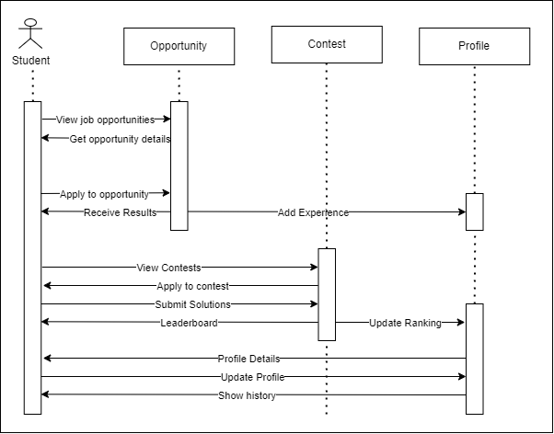

**Collaboration**

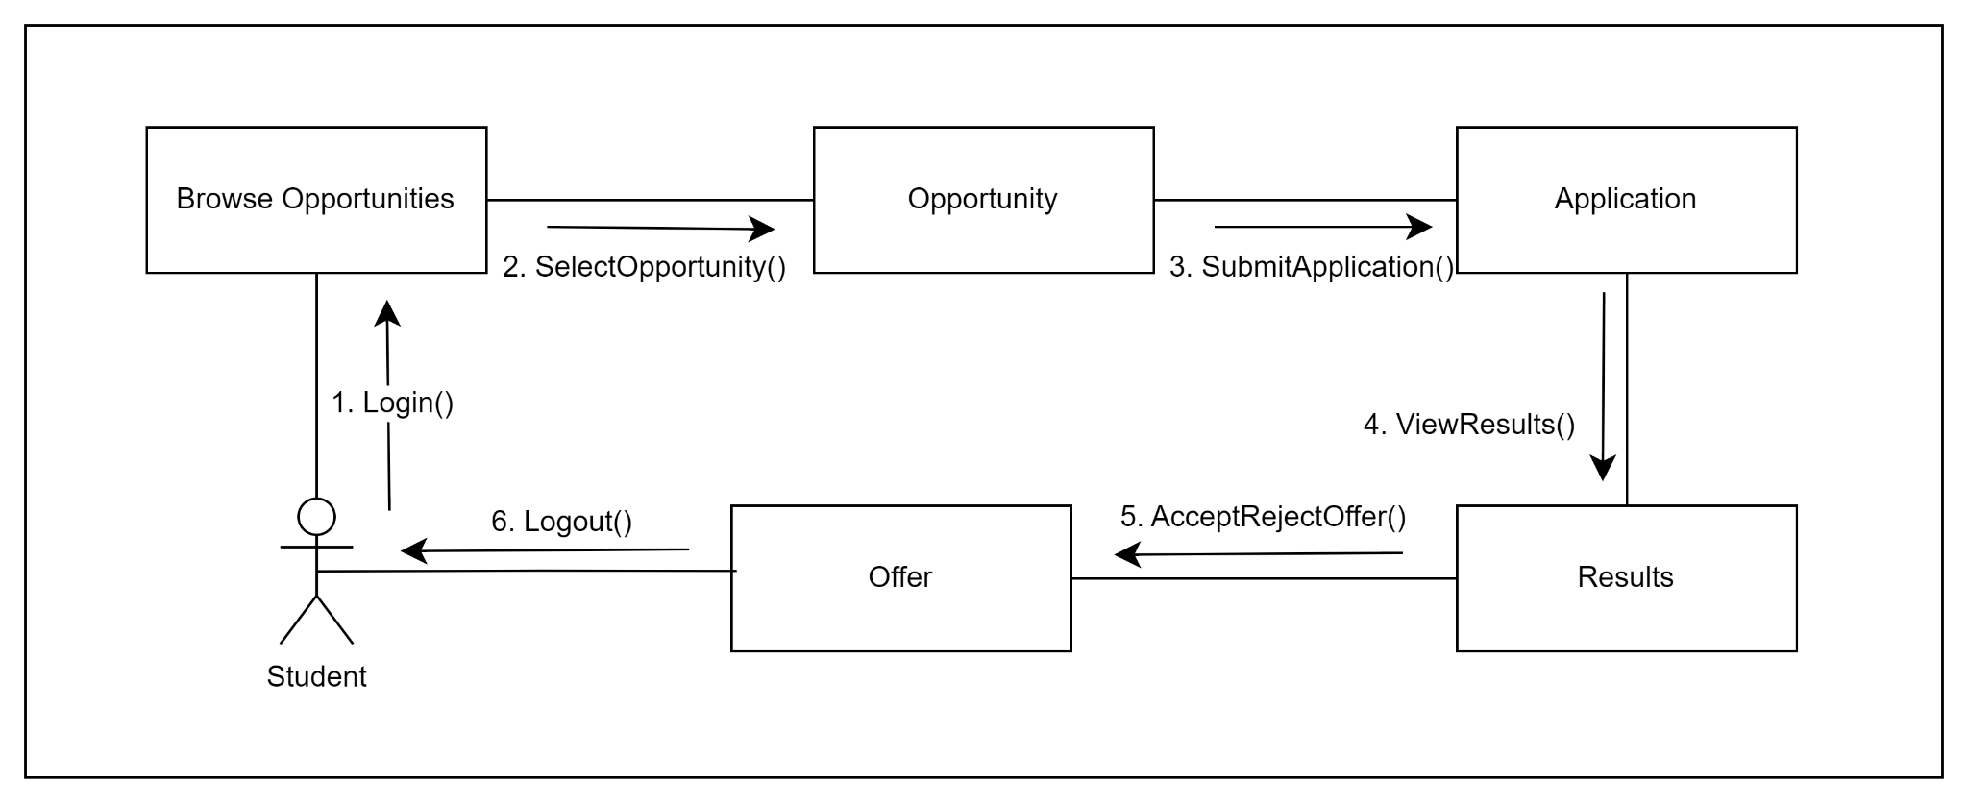

State

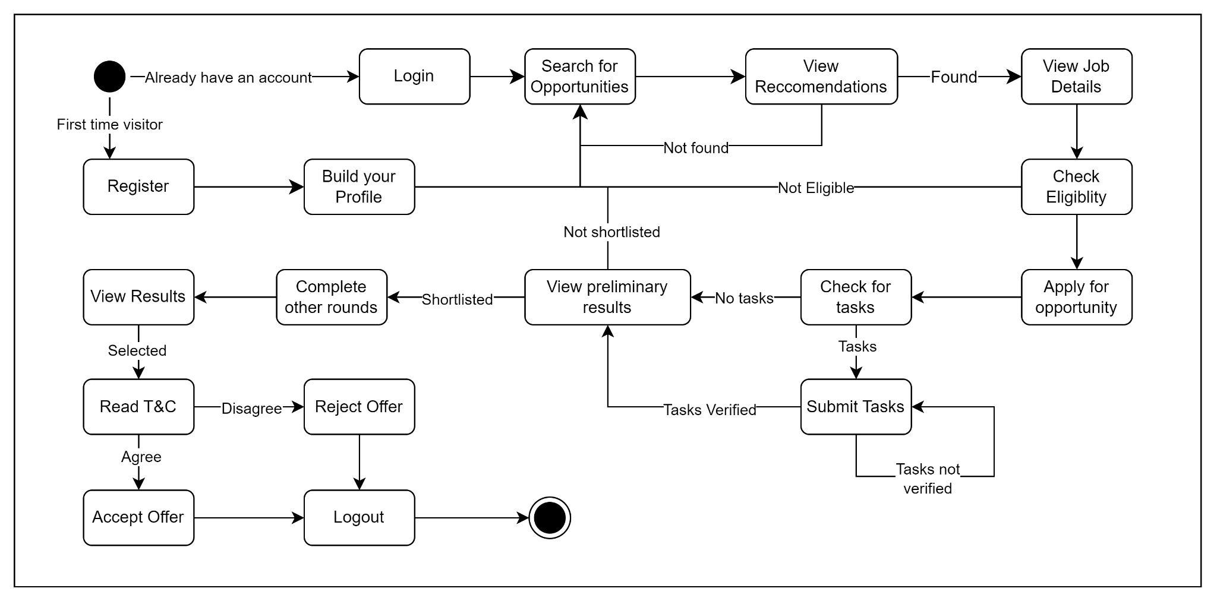

**Conclusion:** Therefore we have implemented Sequence, Collaboration and State diagram for our project SkillDekho

**SE Experiment 6**

**Aim:** Estimate effort and cost required using FP/COCOMO for the project. Create WBS and Gantt Chart for the same.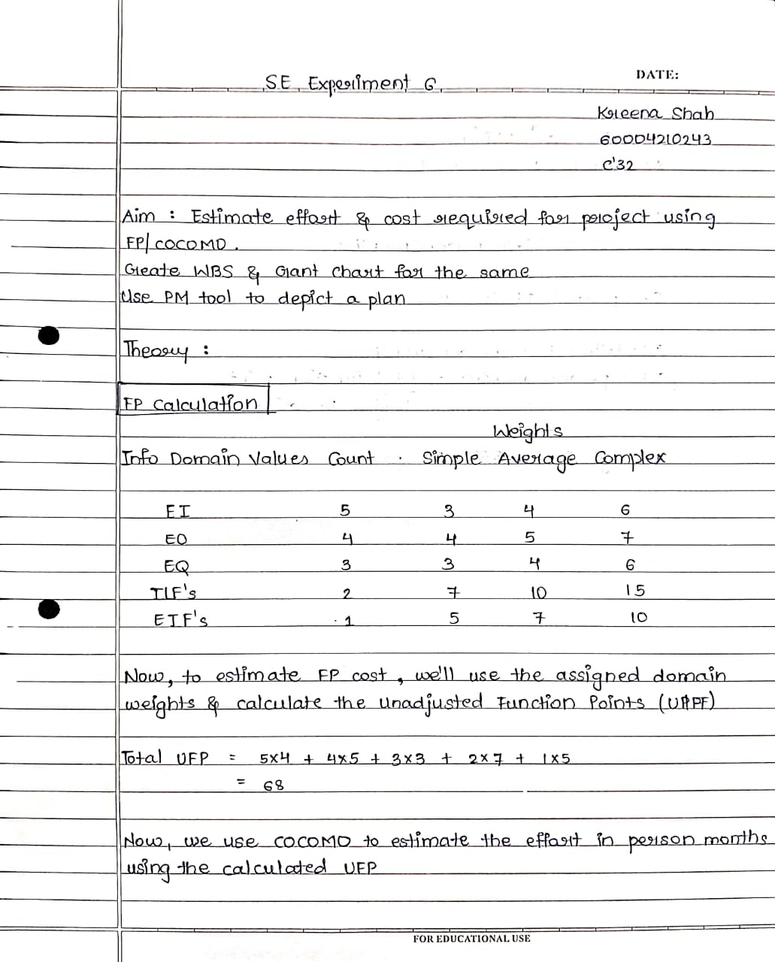

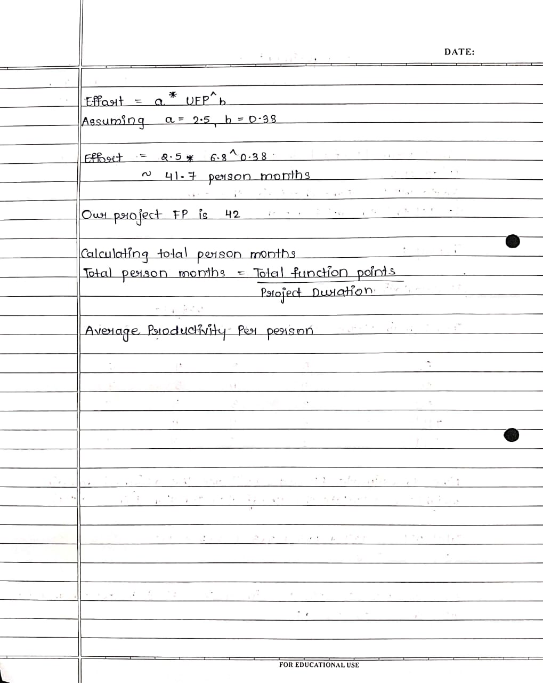

FP Cost Estimation

| Information Domain Value | Count | Simple | Average | Complex |
| --- | --- | --- | --- | --- |
| External Inputs | 5 | 3 | 4 | 6 |
| External Outputs | 4 | 4 | 5 | 7 |
| External Inquiries | 3 | 3 | 4 | 6 |
| Internal User Interface | 2 | 7 | 10 | 15 |
| External User Interface | 1 | 5 | 7 | 10 |

External Inputs (EI):

Count: 5

* User registration
* User login
* Profile update
* Job opportunities
* Eligibility criteria

Complexity Scale: Average

External Outputs (EO):

Count: 4

* Search results display
* Leaderboard and ranking
* Profile view
* Job recommendation

Complexity Scale: Average

External Inquiries (EQ):

Count: 3:

* Job filters
* Candidate filters
* Contest Problem types

Complexity Scale: Simple

Internal Logic Files (ILF):

Count: 2

* User profile data
* Job database

Complexity Scale: Average

External Interface Files (EIF):

Count: 1

* Integration with external authentication system

Complexity Scale: Average

Total UFP = (EI * 4) + (EO * 5) + (EQ * 3) + (ILF * 7) + (EIF * 5)

= (5 * 4) + (4 * 5) + (3 * 3) + (2 * 7) + (1 * 5)

= 20 + 20 + 9 + 14 + 5

= 68

Effort = a * (UFP)^(b)

Let's assume typical values for a and b: a = 2.5, b = 0.38

Effort = 2.5 * (68)^(0.38)

≈ 41.7 person-months

To calculate the total person-months and average productivity per person,

Team Size: 8 developers

Project Duration: 7 months

Total Person-Months = Effort / Project Duration

= 41.7 person-months / 7 months

≈ 5.957 person-months per month

Average Productivity per Person = Total Person-Months / Team Size

≈ 5.957 person-months per month / 8 developers

≈ 0.744 person-months per developer per month

**Work Break Down**

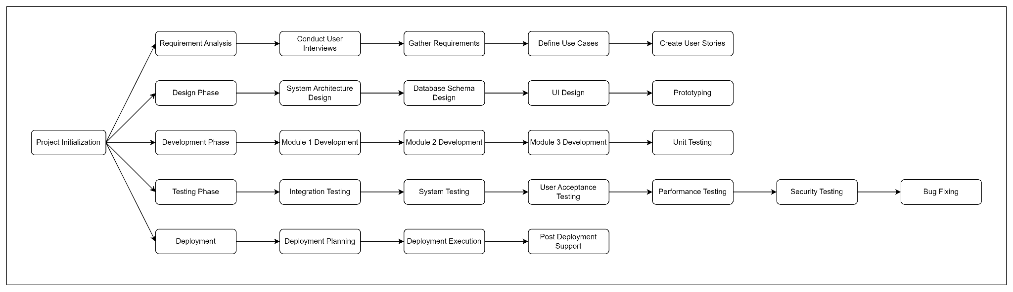

**Gantt Chart**

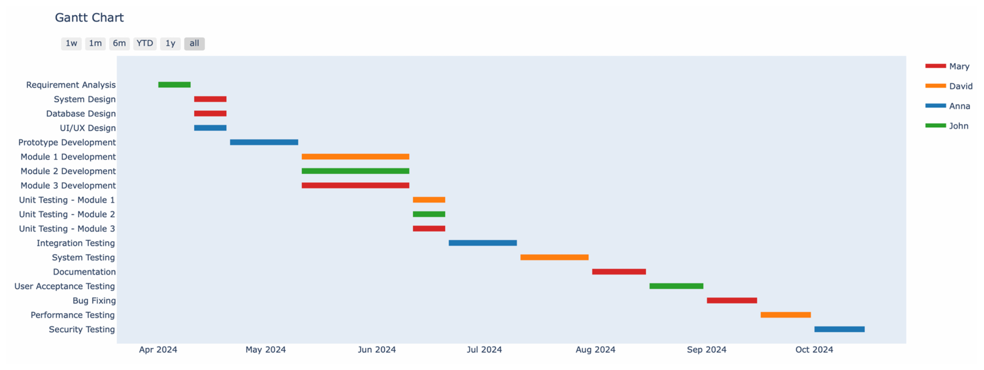

**Conclusion:** Therefore we have implemented the effort and cost required using FP/COCOMO for the project. Create WBS and Gantt Chart for our project SkillDekho

**SE Experiment 8**

**Aim:** Design test RMMM plan.

**Theory**: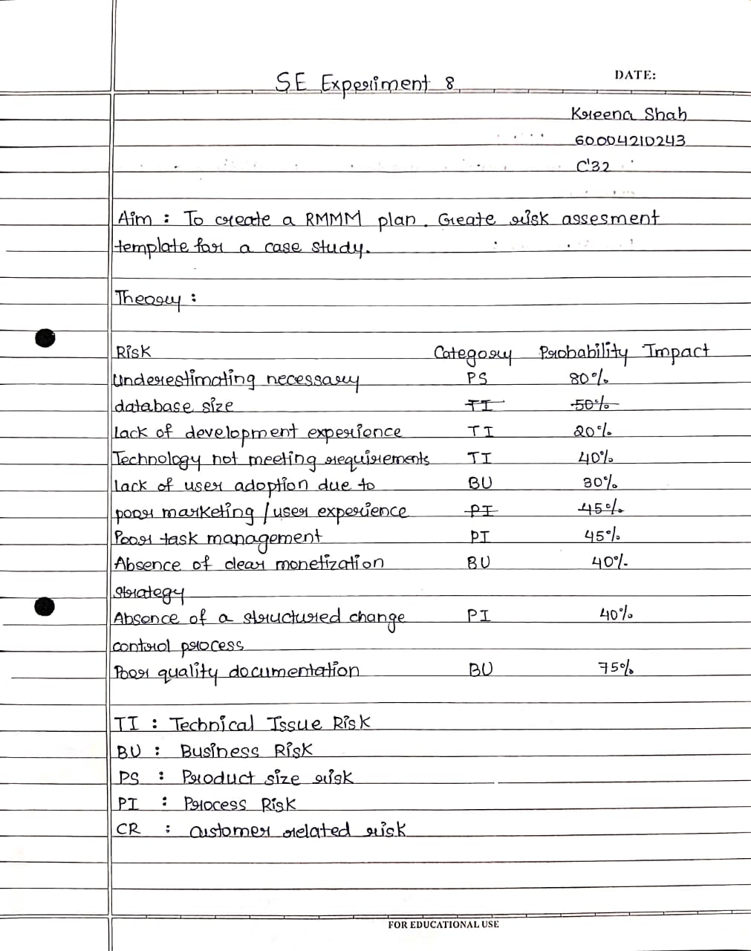

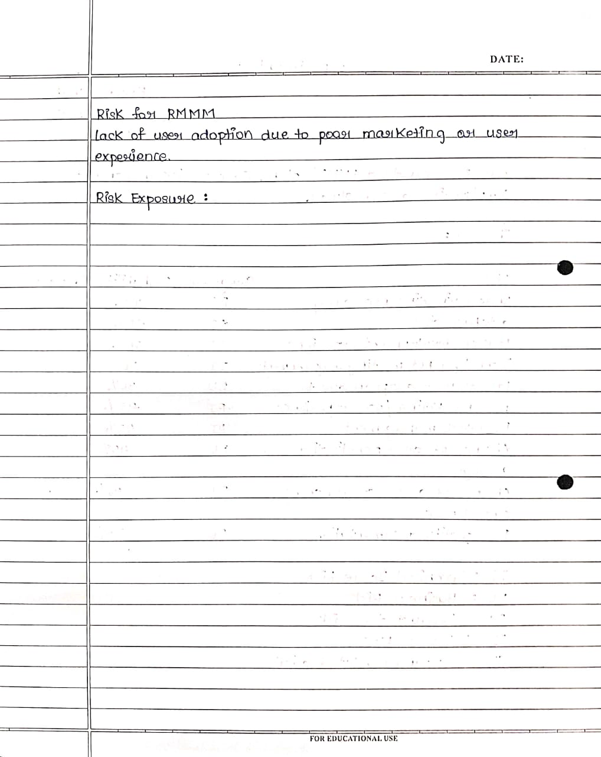

RMMM

| Risk Information sheet | | | |
| --- | --- | --- | --- |
| Risk ID: P02-4-32 | Date: 02-05-2024 | Prob:70% | Impact: Critical |
| Description: Lack of user adoption due to poor user experience or lack of engaging content on the SkillsDekho platform. | | | |
| Refinement/context:   1. Subcondition1: Unintuitive user interface or navigation making it difficult for users to access coding problems and learning resources. 2. Subcondition2: Lack of diverse and engaging coding problems or learning content. 3. Subcondition3: Poor performance or frequent technical issues on the platform. | | | |
| Mitigation/monitoring:   1. Conduct usability testing with target users and gather feedback to improve the user experience. 2. Collaborate with educational institutions and industry experts to curate high-quality coding problems and learning resources. 3. Implement robust performance monitoring and issue tracking systems to identify and resolve technical issues promptly. | | | |
| Management/contingency plan/trigger:   1. Allocate a budget of INR 3,00,000 for user experience (UX) design and usability improvements. 2. Partner with educational content providers or hire subject matter experts to enhance the learning resources (Estimated cost: INR 5,00,000 per year). 3. Implement load testing and performance optimization strategies (Estimated cost: INR 2,00,000). | | | |
| Current Status - Requires ongoing monitoring and mitigation strategies. | | | |
| Originator: Kapil Kashyap | | Assigned To: Kreena Shah | |

**Conclusion**: Thus we have implemented RMMM for our project SkillDekho

**SE Experiment 9**

**Aim:** Study of Configuration Management using GitHub

**Theory:**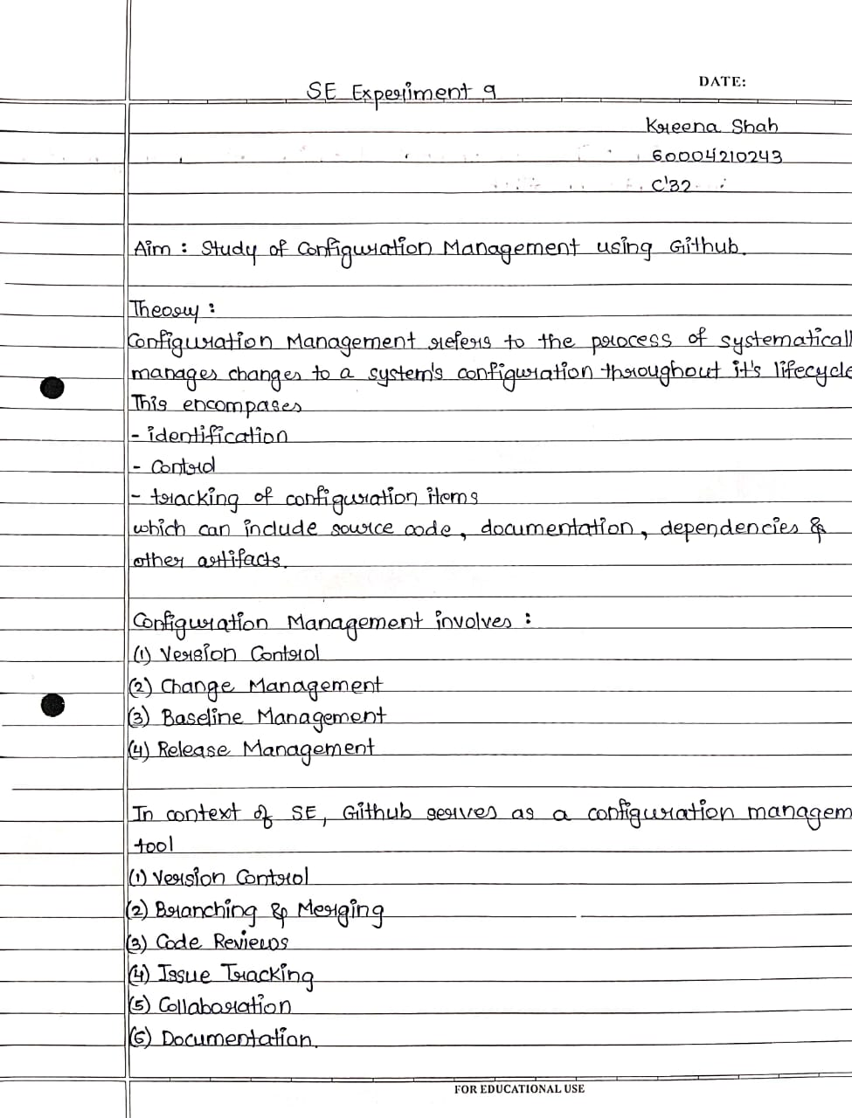

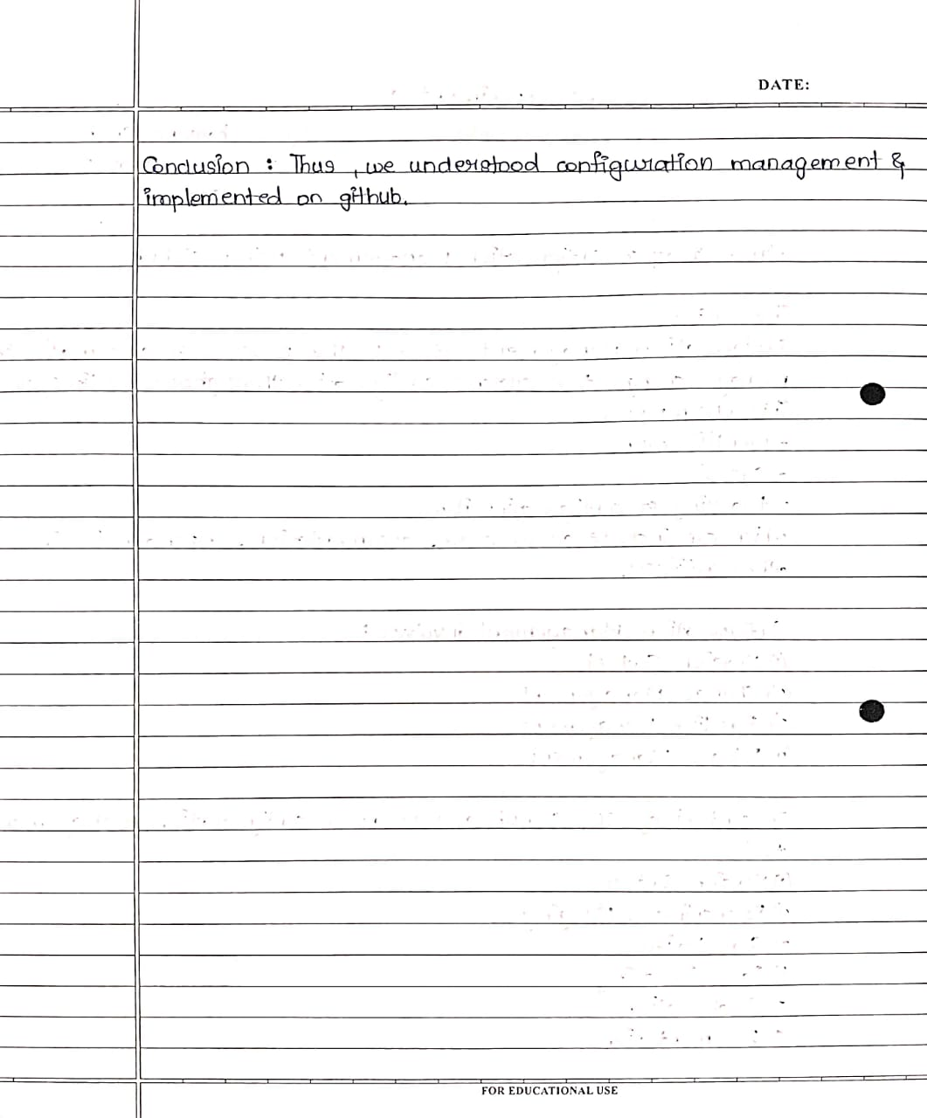

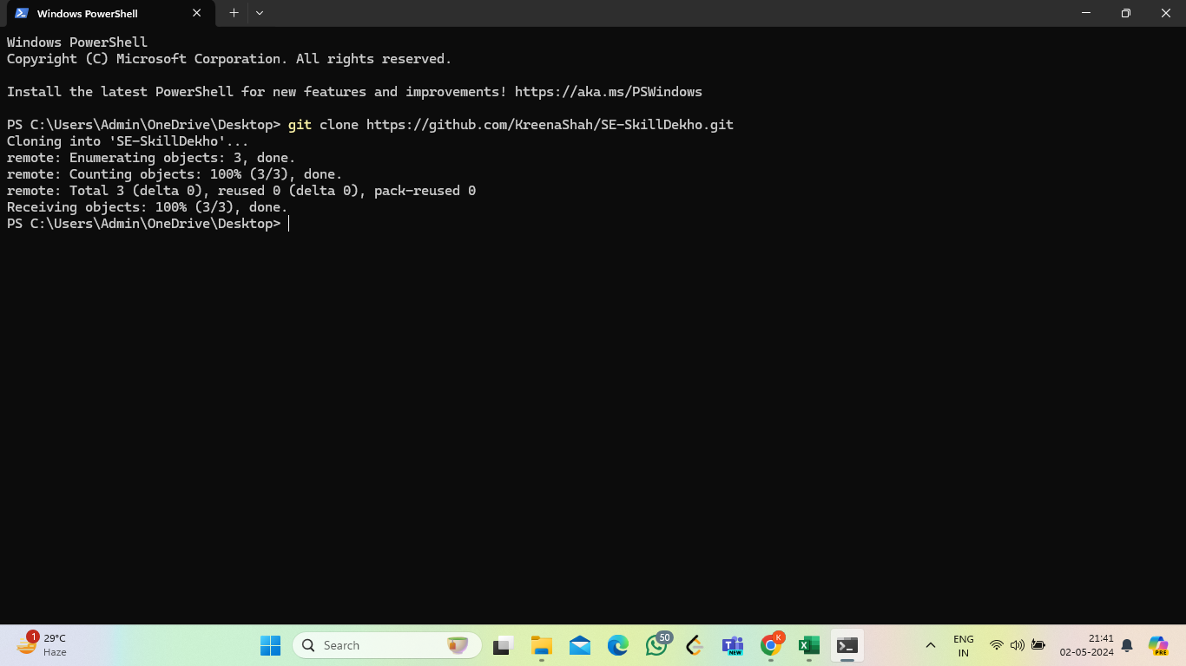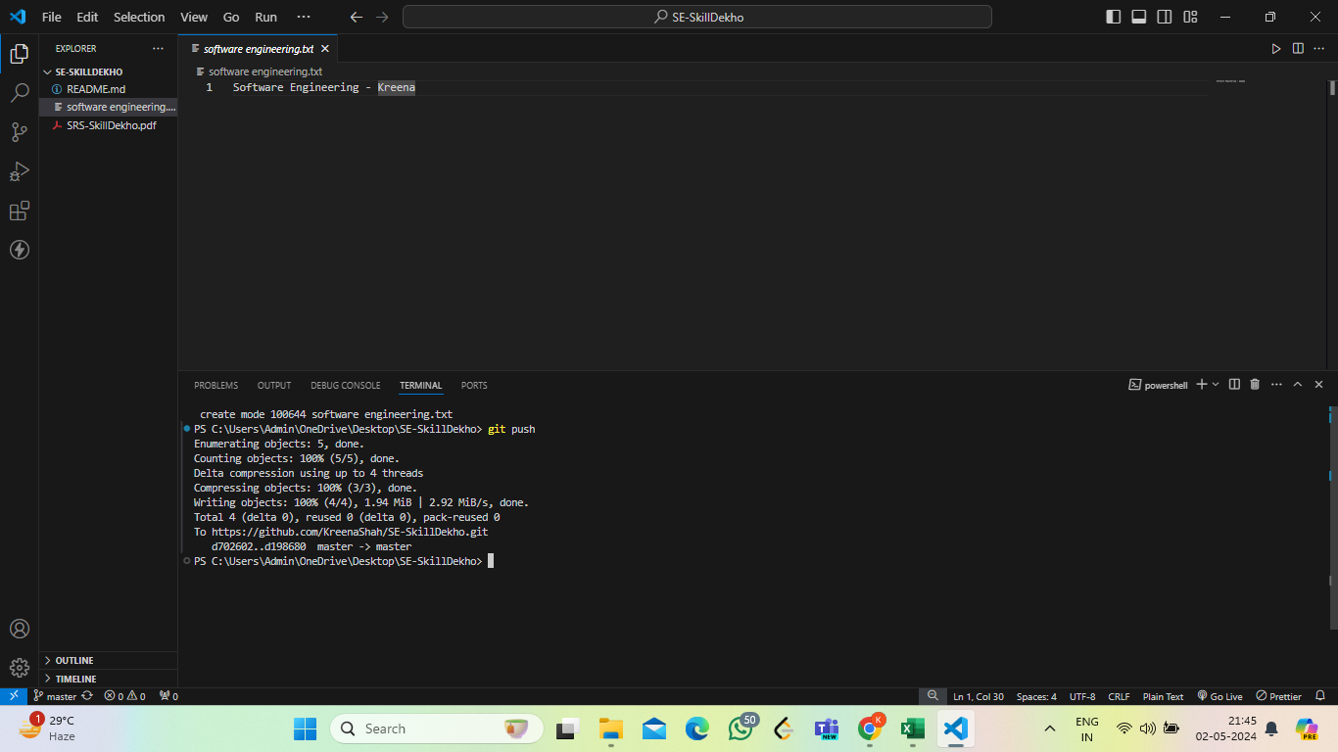

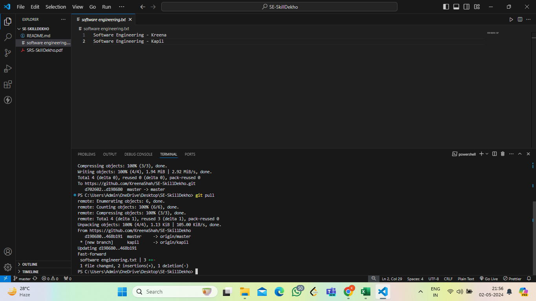

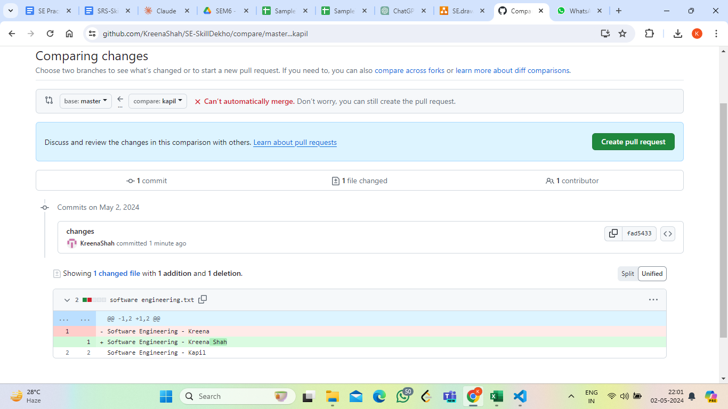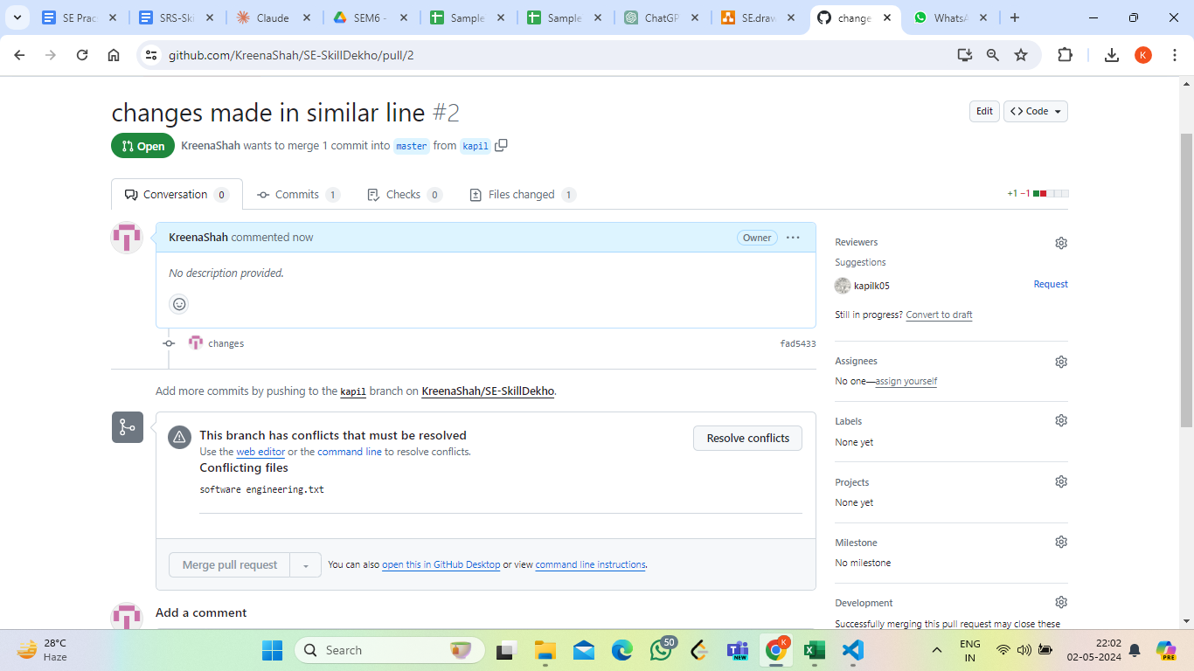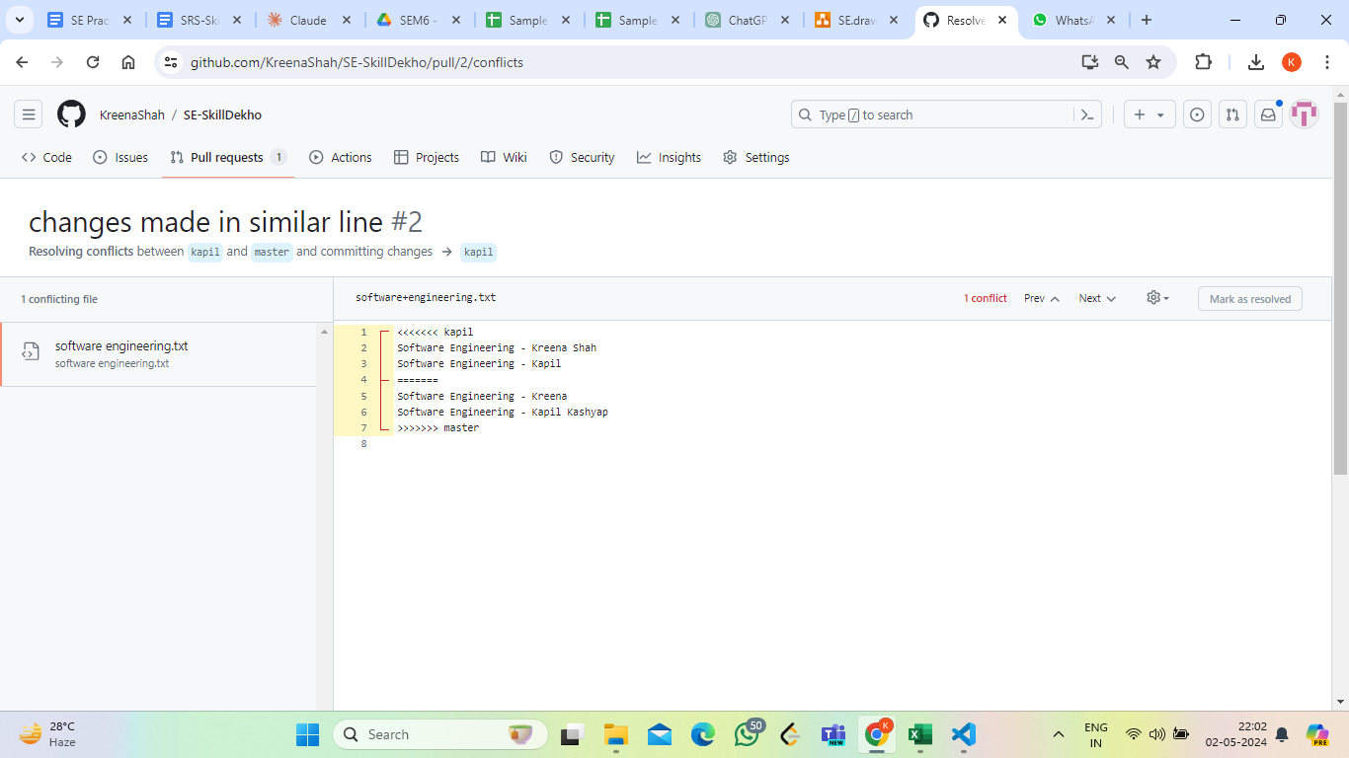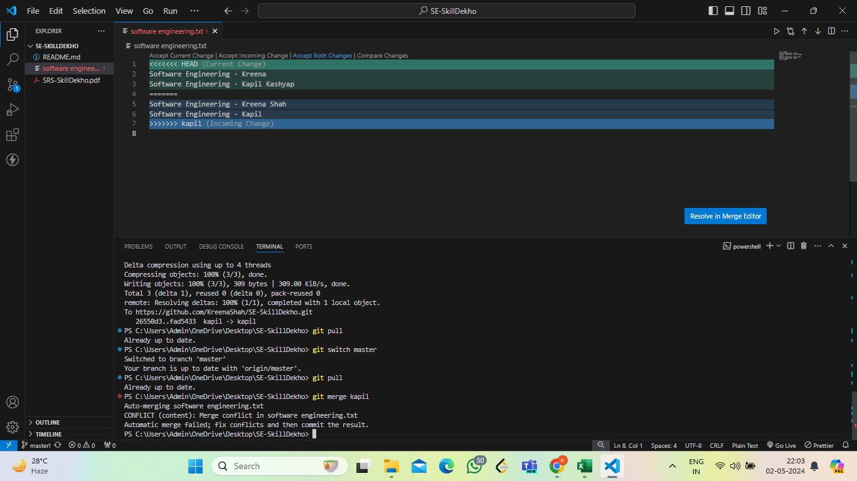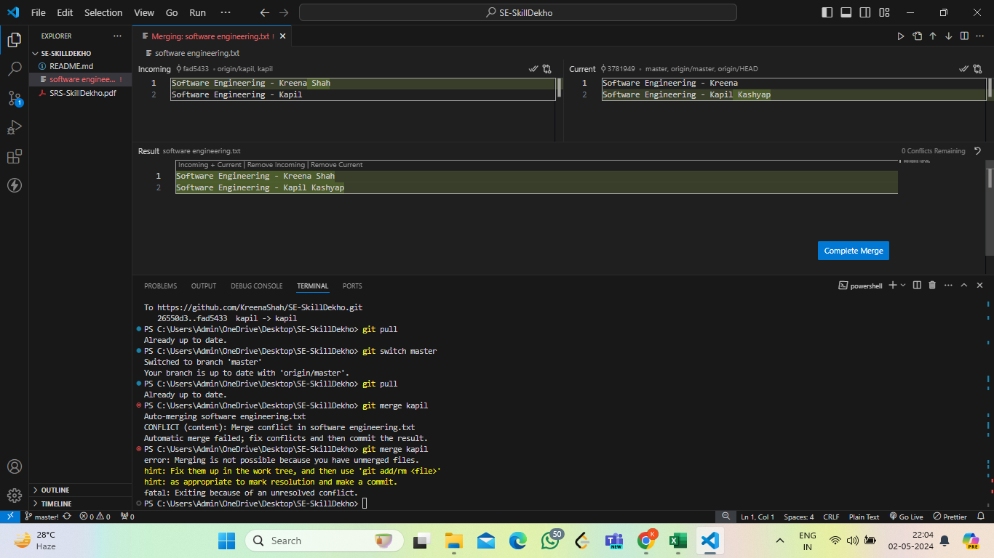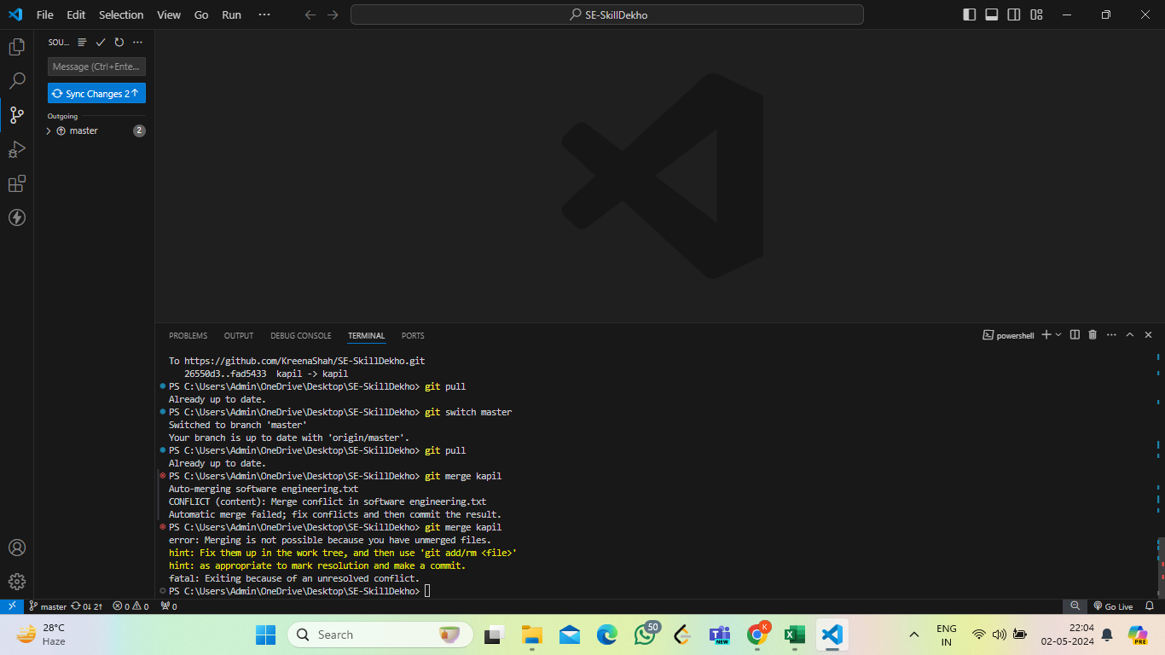

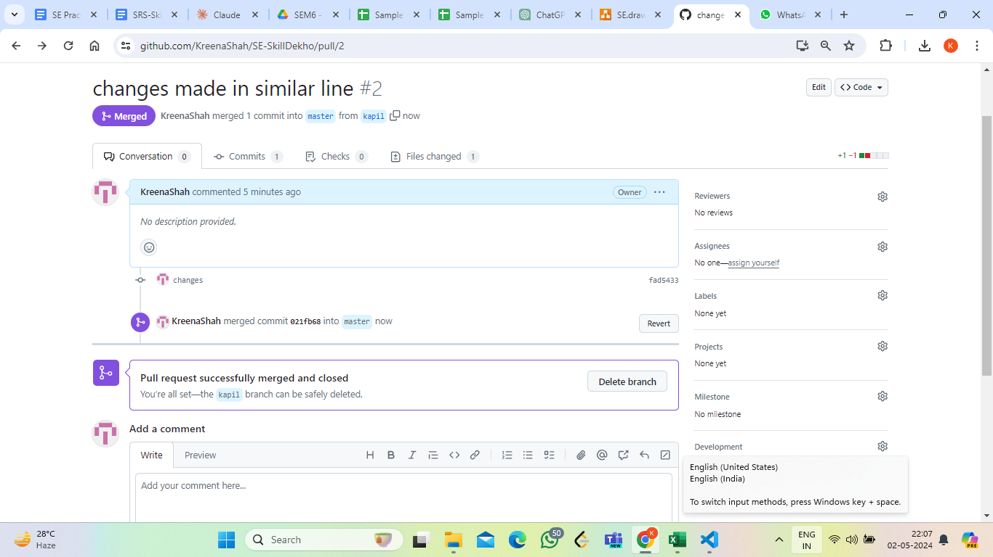

**Conclusion**: Thus we have implemented Configuration Management using GitHub

Experiment 10